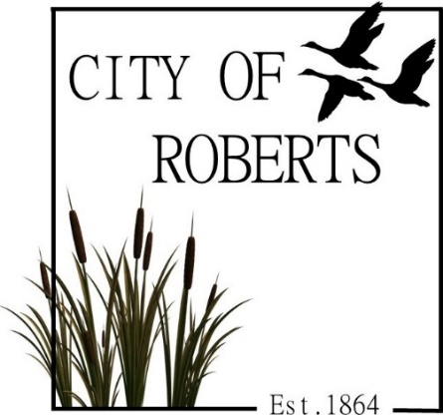
Roberts City Council Meeting Agenda
January 13, 2026
Roberts City Hall 7:00 P.M.

Open Meeting
Opening Prayer
Pledge of Allegiance
Vote to Approve City Council Hearing & Meeting Minutes for December 9, 2025 Action Item
Discussion & Vote – Ordinance 2026-570 Right-of-Way Construction Permits/License Action Item
Review and Approve the Bills Action Item
Swearing in Councilmembers
Elect City Council President Action Item
Sheriff’s Report
State of the City
Library Report
Appoint and Confirm Library Board Member Action Item
Update – Roberts Community Center
Update – Water Facility Improvement Project
Discussion – Penny Policy
Discussion – R4 Zoning
Discussion & Vote – Resolution 2026-0113 Action Item
Discussion & Vote – Lease of 651 N 2858 E Action Item
Discussion & Vote – Lease Amendment for 653 N 2858 E Action Item
Discussion & Vote –Building Permit for 653 N 2858 E Action Item
Maintenance Report
Adjourn Action Item

